Project Design Phase-II
Technology Stack (Architecture & Stack)

Date | 25/09/2026
Team ID | SWTID-2026-3184
Project Name | AI Studdy Buddy
Maximum Marks | 4 Marks

Technical Architecture:
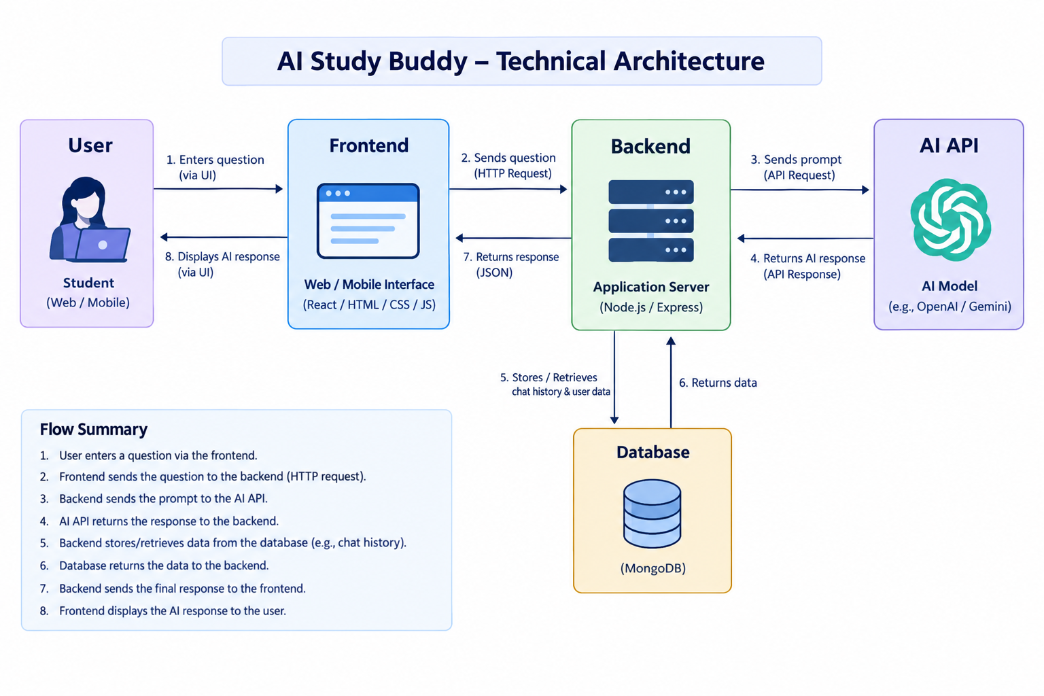

Table-1 : Components & Technologies:
S.No | Component | Description | Technology
 | User Interface |  | HTML, CSS, JavaScript
  Provides the interface through which students enter questions and view AI-generated responses.
 | Application Logic-1 | Handles user input, request processing, and communication between the interface and backend. | JavaScript, Node.js
 | Application Logic-2 | Manages API requests and sends study questions/prompts to the AI service. | Node.js, Express.js
 | Application Logic-3 | Processes the AI response and sends the result back to the user interface. | JavaScript, Node.js
 | Database | Stores and manages application data such as user-related information or chat data, where applicable. | MongoDB
 | Cloud Database | Provides database hosting and remote access for the application. | MongoDB Atlas
 | File Storage | Stores project files and static application resources required by the application. | Local File System
 | External API-1 |  | Gemini API
  Provides AI capabilities by processing user questions and generating study-related responses.
 | External API-2 | Not applicable; the application currently uses one primary external AI API.
 | Machine Learning Model | AI model used to understand prompts and generate responses for study assistance.
  prompts and generate responses for study assistance.
  Gemini AI Model
 | Infrastructure (Server / Cloud) | Application is developed and tested locally and can communicate with the database and external AI API. | VS Code, Node.js, Localhost, MongoDB Atlas

Table-2: Application Characteristics:
S.No | Characteristics | Description | Technology
 | Open-Source Frameworks | The application uses open-source technologies for frontend development and backend/API handling. | Node.js, Express.js, HTML, CSS, JavaScript
 | Security Implementations | API credentials are kept outside the main source code using environment configuration. Sensitive credentials should not be uploaded to the public repository. | .env, API Key Protection, Environment Variables
 | Scalable Architecture |  | Node.js, Express.js, MongoDB
  The application separates the user interface, backend logic, database, and external AI service, allowing individual components to be improved or scaled independently.
 | Availability | The application depends on the availability of the local server, database service, and external AI API. Proper error handling helps manage temporary API failures. | Node.js, MongoDB Atlas, Gemini API
 | Performance | The application sends user queries to the AI API and returns the generated response. Performance is evaluated using response time, throughput, error rate, CPU usage, and memory usage. | Node.js, Express.js, JMeter

